

DataStax Essentials

For Microsoft AMP Day’s

Date June 9, 2016

# Table of Contents

Table of Contents 2

Introduction 3

Installation and Configuration 3

Resource Requirements 3

Microsoft Azure Setup 4

Accessing the Cluster 12

Where is my Cluster? 12

Search and Analytics Setup 12

Accessing DataStax Tools 13

Hands-On Workshops 14

Creating a Keyspace, Table, and Queries 14

Hands On Cassandra Primary Keys 15

The secret sauce of the Cassandra data model: Primary Key 15

Here's how to do the exercise 15

Cassandra Data Model and Query Pro-Tips 16

Hands On Cassandra Consistency 17

Let's play with consistency! 17

This DeathStar is Operational! 17

Hands On DSE Search 20

Search Essentials 20

Retail Book Workshop 21

Hands On DSE Analytics 23

Getting Started with DSE Ops 24

About DataStax 26

# Introduction

In this session, you'll learn all about DataStax Enterprise. It's a mix between presentation and hands-on. This is **obviously** your reference for the hands-on content. This guide will be helpful after this event as a tutorial…so keep it around!

Throughout this document, there will be code and commands listed. The context of how you run commands will be denoted either by a ‘$’ for Linux based command-line operations, or CQL commands that either don’t have a prompt, or are preceded by ‘cqlsh>’.

And before we go on, a quick explanation of what CQL, CQLSH and other aspects of Cassandra and DataStax Enterprise is in order:

The Cassandra Query Language (CQL) is the primary language for communicating with the Cassandra database. The most basic way to interact with Cassandra is using the CQL shell, cqlsh. Using cqlsh, you can create keyspaces and tables, insert and query tables, plus much more. If you prefer a graphical tool, you can use DataStax DevCenter. For production, DataStax supplies a number of drivers so that CQL statements can be passed from client to cluster and back. Other administrative tasks can be accomplished using OpsCenter.

# Installation and Configuration

## Resource Requirements

Your laptop will need to be able to access the cluster that you create on Microsoft Azure. Thus, you will need to install an ssh client. For MacOS, this is typically already installed. For Microsoft Windows, you can install putty. Putty can be found at:

<http://www.putty.org>

Also, DataStax offers a GUI interface, called DevCenter. DevCenter is an easy-to-use visual query tool that allows developers to create and run CQL queries and commands against Apache Cassandra and DataStax Enterprise. You can download and install this at:

<https://academy.datastax.com/downloads/ops-center#devCenter>

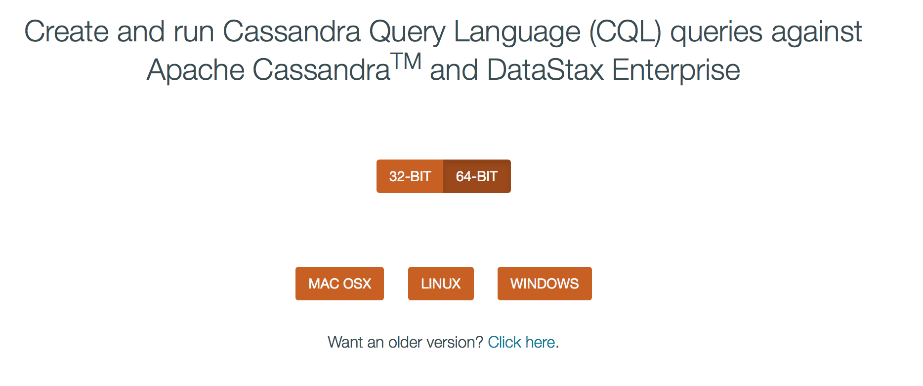

Connecting to the cluster from DevCenter:

* Simply add a new connection
* Enter a name for your connection
* Enter any of the IP addresses (determined from below) as a contact host



## Microsoft Azure Setup

To begin with, you will need to setup an Azure cluster of VM Images through the Azure portal. You can access Azure from:

<https://portal.azure.com>

Once you have logged in and accessed the portal, click on the Marketplace:

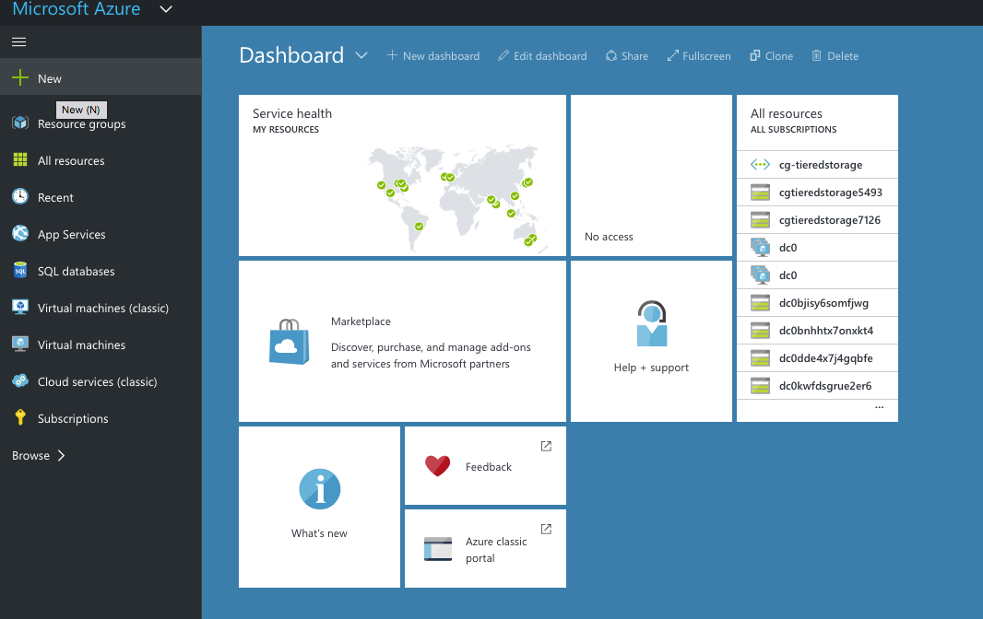

Now, you will be able to search for “DataStax Enterprise” for setting up your cluster.

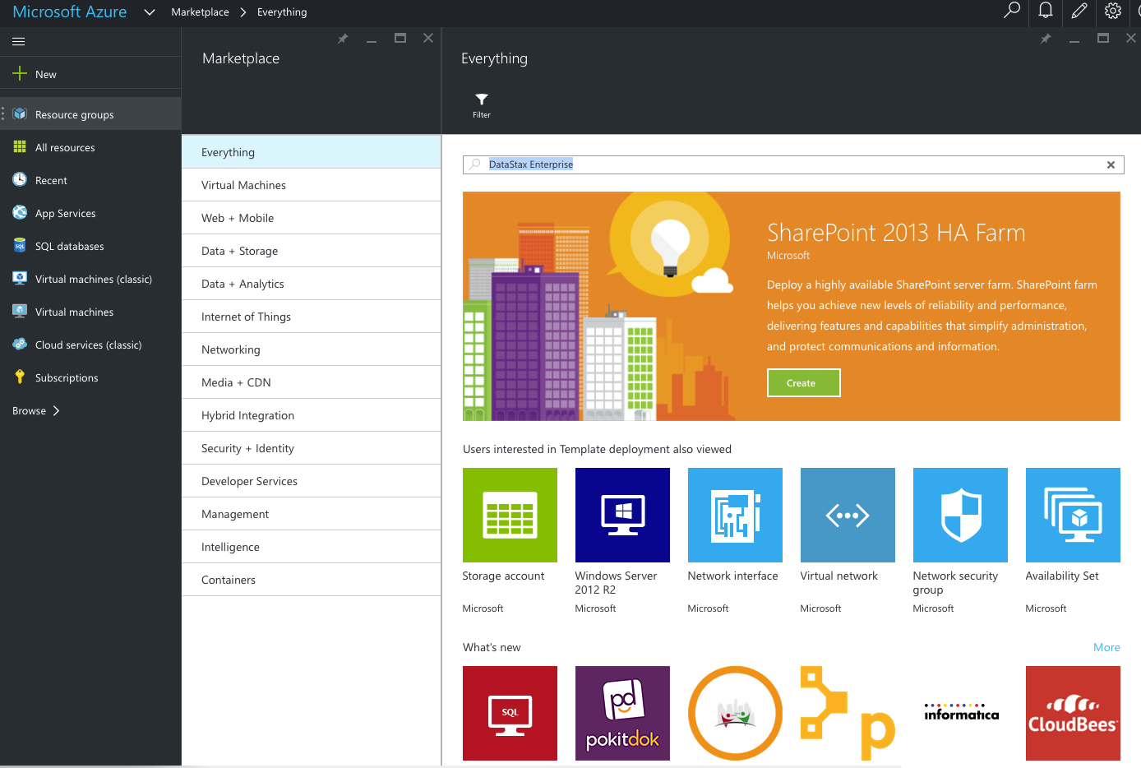

Now choose the resulting DataStax Enterprise option:

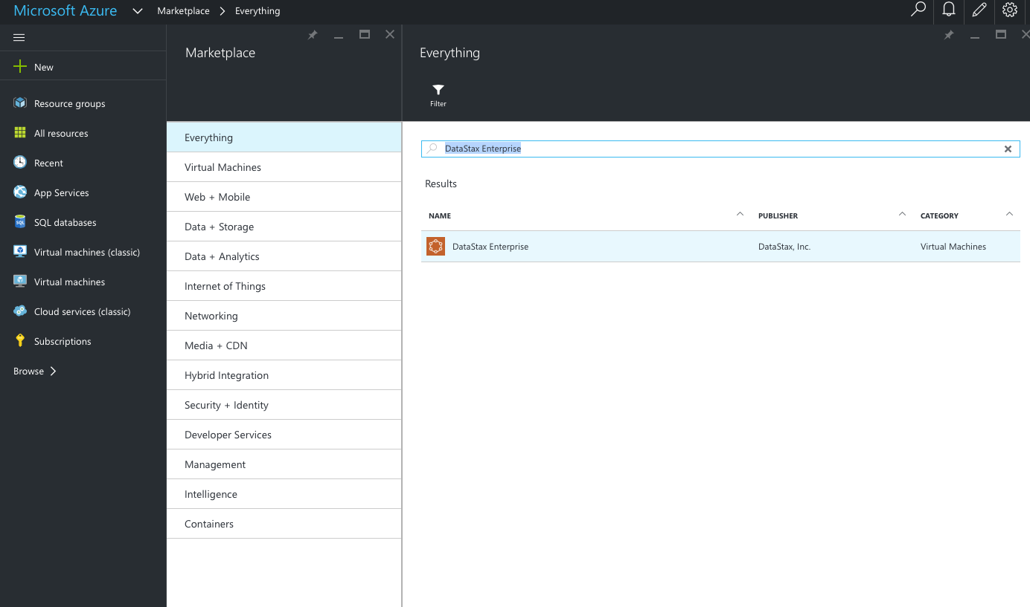

Next, Click on “Create”:

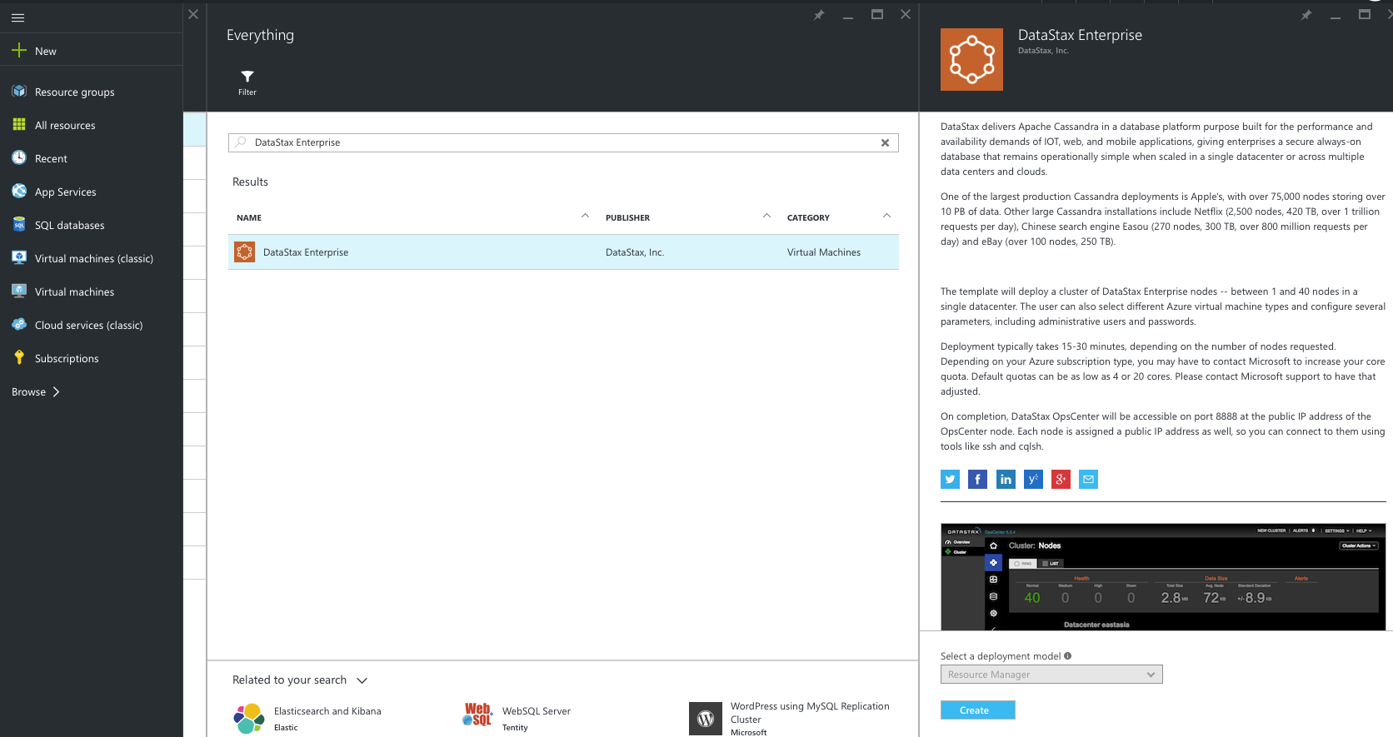

You’ll be presented with a template to fill in your options. Here are suggested setup options for your hands-on cluster:

* Admin Username: datastax
* Admin Password: C@ssandra
* Subscription: <Choose your subscription>
* Resource Group: <Select “Create new” and enter a name that is representative of your name, e.g. cdroukas_datastax>
* Location: <Choose a Location within your region>

Click *OK* when done.

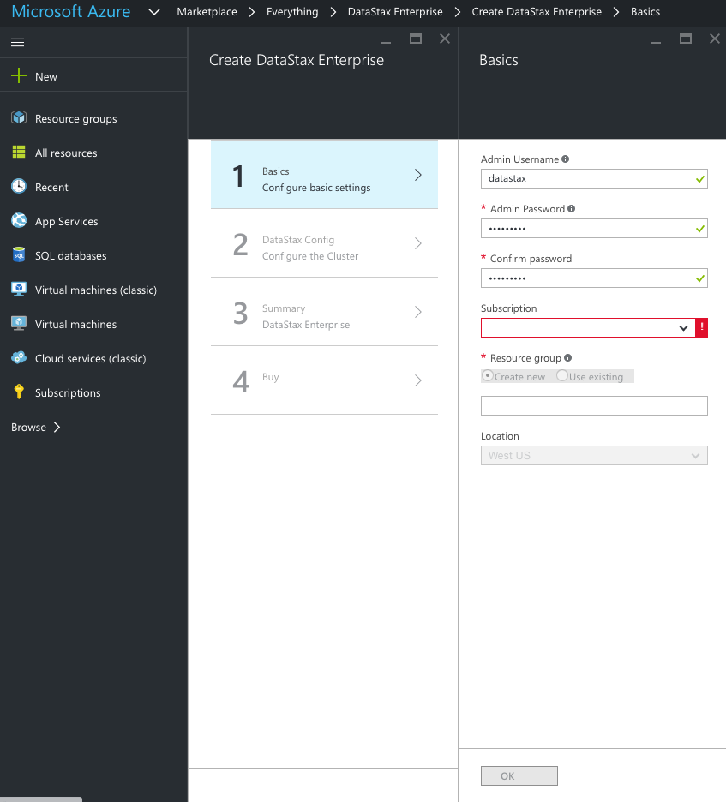

Now click on Section 2, and select the number of nodes you will be setting up (recommended: 3).

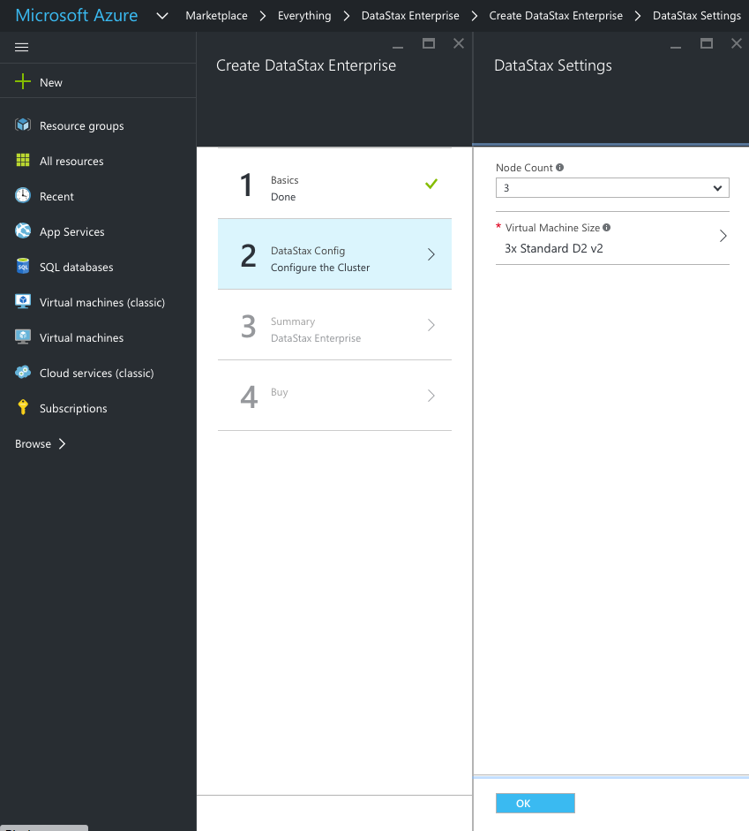

You can also change the type of Virtual Machine Size that you want to use. Typically, you will want to create a cluster with VM’s that are no smaller than D12’s. However, for this session, a D4 should be adequate.

Now click *OK* when done.

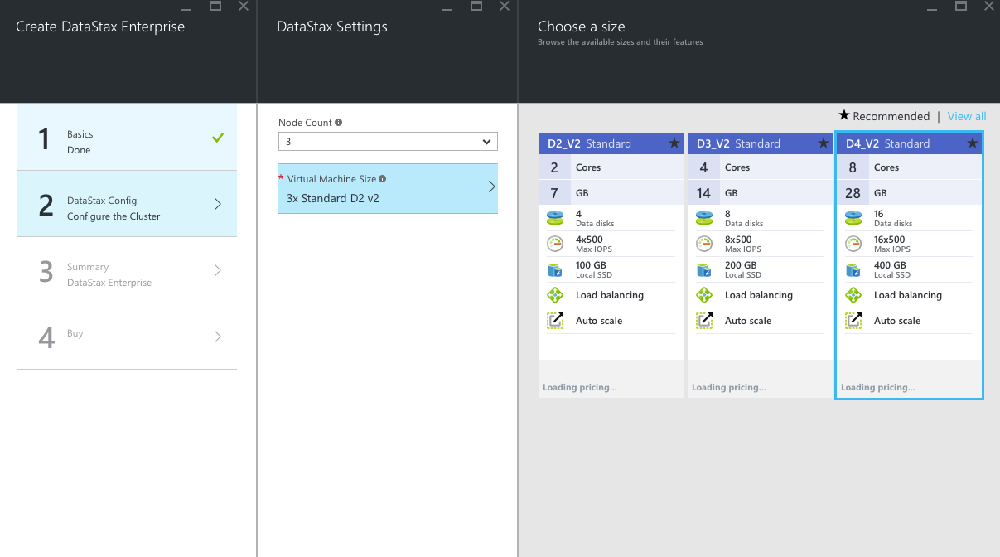

Now click on section number 3 and review your choices on the Summary page, then click *OK*.

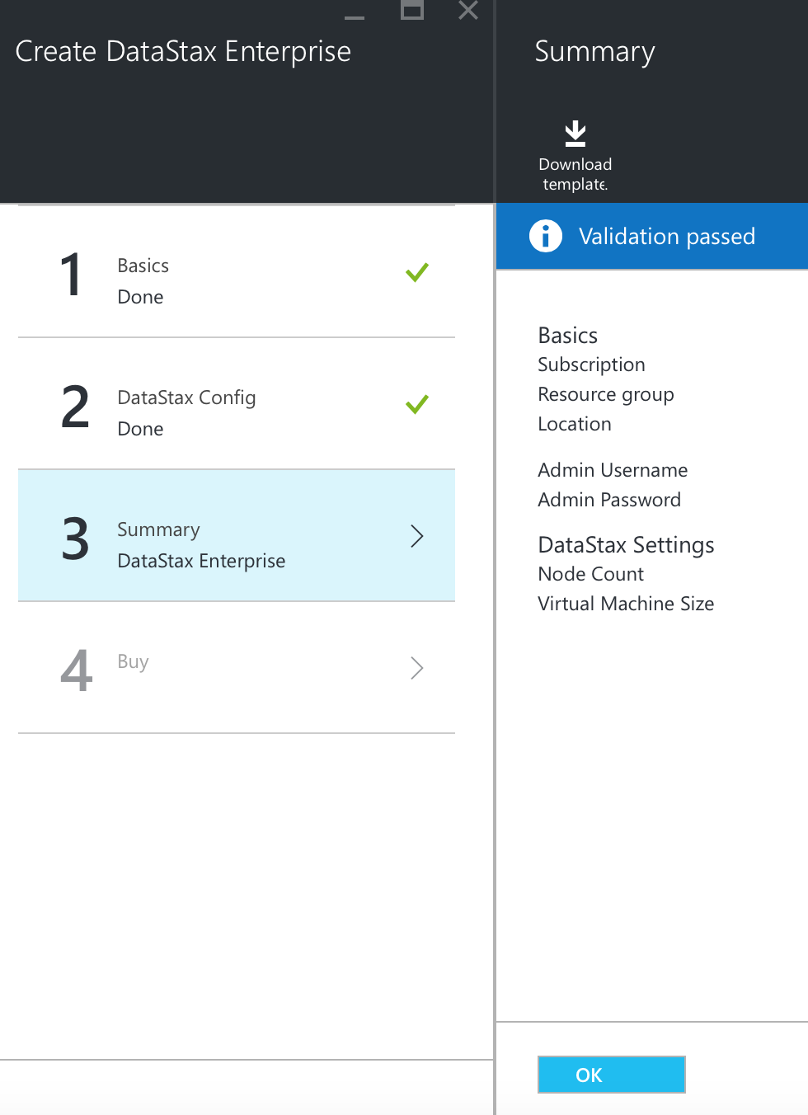

Finally, click on section number 4 and click *Create* to create your cluster.

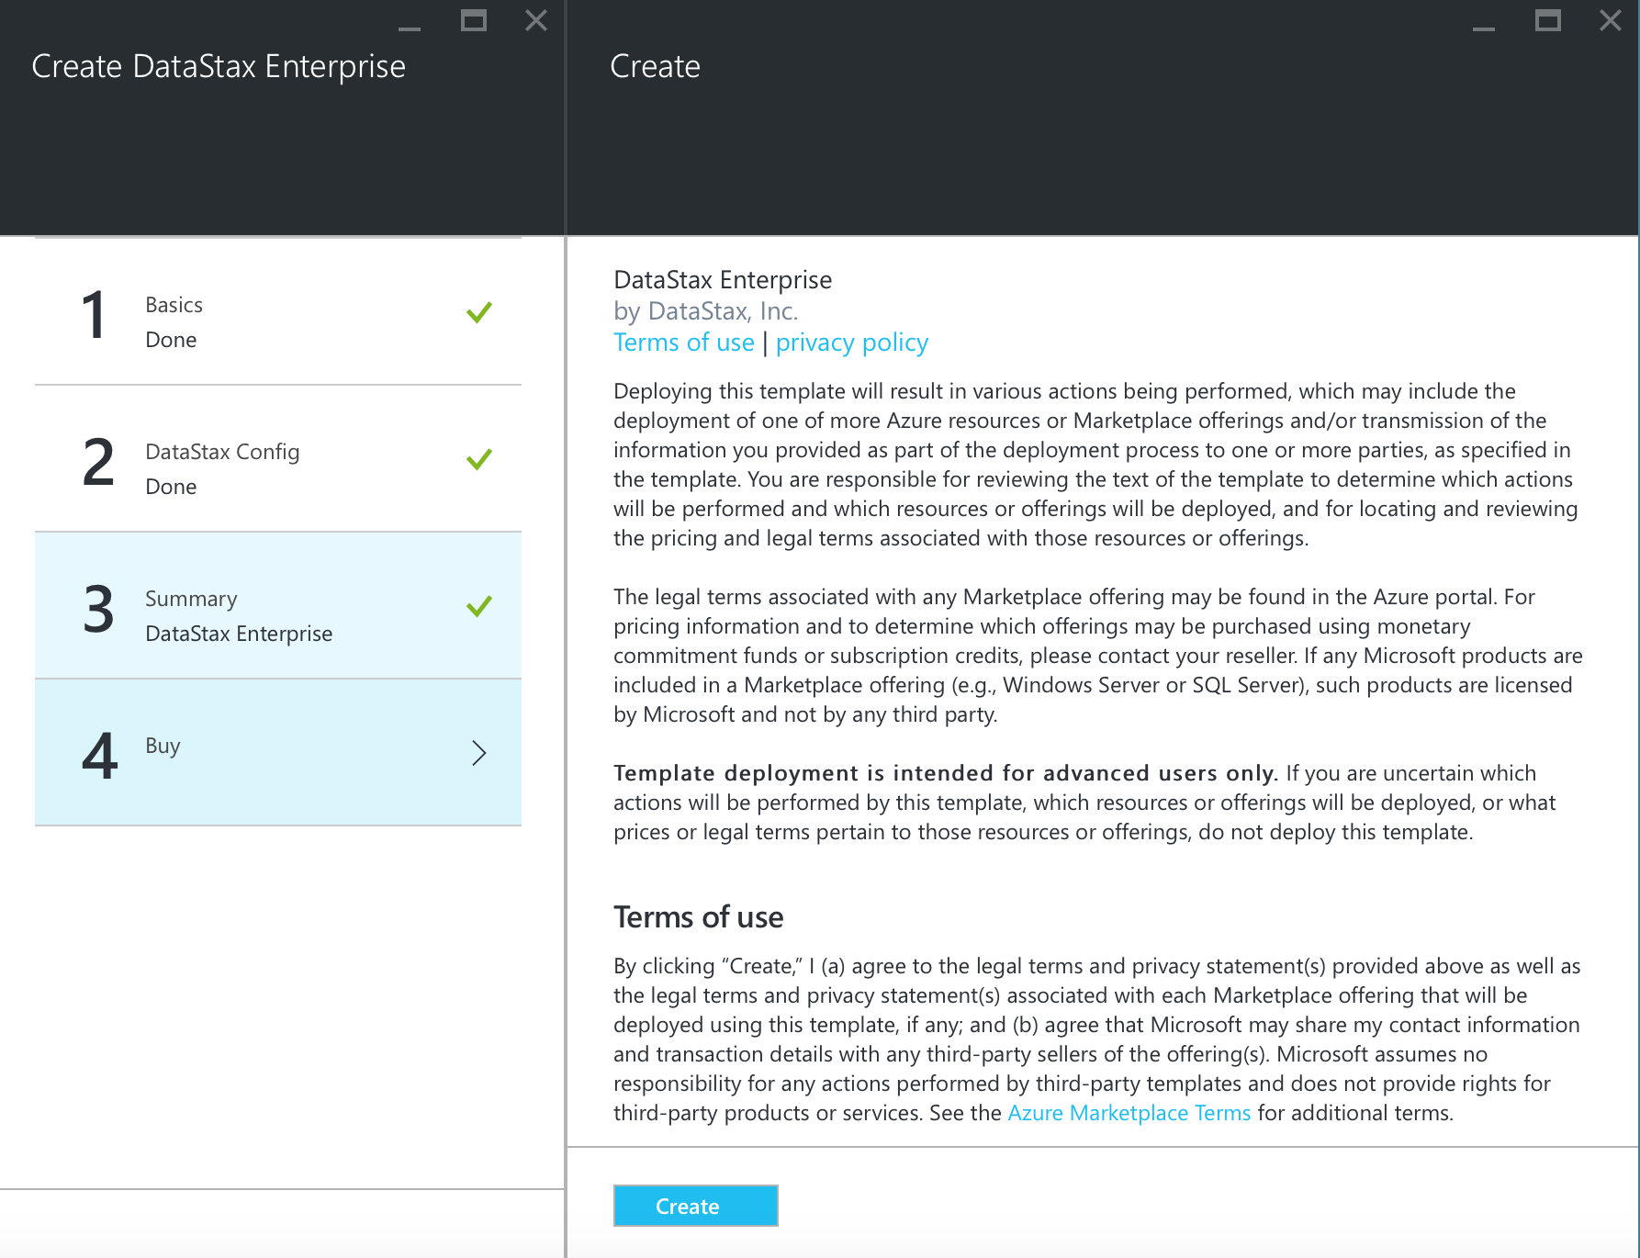

You have now successfully created your DataStax Enterprise cluster in Azure. This will take some time to create, so be patient (15-20 minutes). You can monitor your progress by clicking on the *Resource groups* in the left pane, and reviewing the objects that you created and the state of their creation.

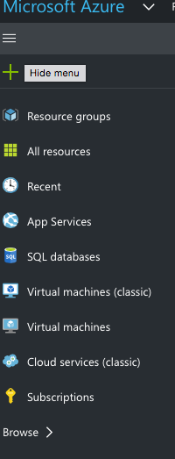

You can view the deployment history:

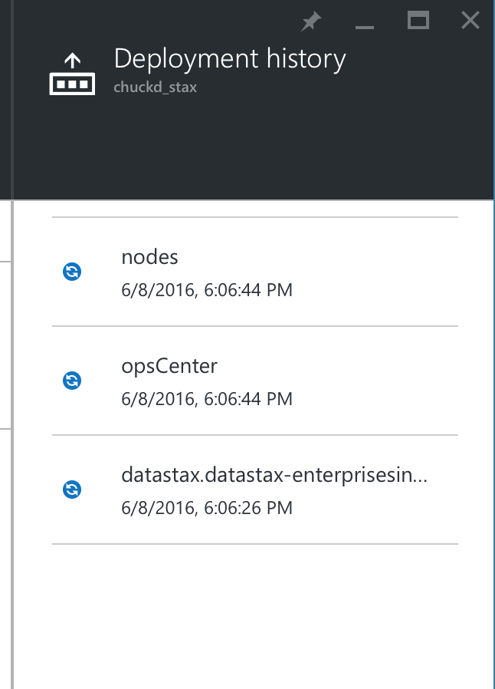

## Accessing the Cluster

Now we have a 3 node cluster for you to play with! The cluster is initially setup as just a single Cassandra Data Center (DC). We will shortly show you how to set it up as a multi-model mixed-use cluster. But first, we need to access the cluster.

### Where is my Cluster?

Determine the IP addresses of all of the nodes in your cluster and write them down. You can do this by selecting the Resource Group that you created, then select each of the nodes, one by one. The naming convention for your 3 nodes will likely be: *dc0vm0*, *dc0vm1* and *dc0vm2*. You can access the nodes either by their Public IP address or their DNS name. You will also need the Public IP address and DNS name for the *opscenter* node as well.

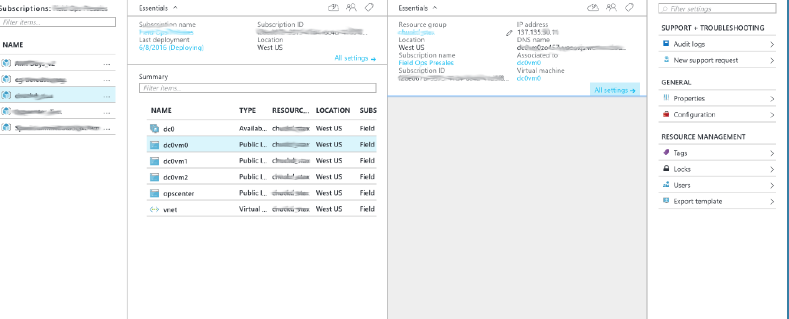

To SSH into the cluster:

$ ssh datastax@*ip_address*

or

$ ssh datastax@*dns_name*

You will be using the login and password you entered from the Azure VM creation steps above (e.g. username: datastax, password: C@ssandra).

### Search and Analytics Setup

To setup DataStax Enterprise to run both the Search and Analytics integrated components on your cluster, follow these steps **on all of your nodes** (dc0vmX only, not opscenter):

$ ssh datastax@*ip_address*

After logging in:

$ sudo vi /etc/default/dse

Change the following:

SOLR_ENABLED=1

SPARK_ENABLED=1

Now save the file. If you need help with “vi”, ask your instructor for assistance. You can also use nano, vim, or any Linux seditor of choice to edit these files.

Now stop and restart the Cassandra server. To begin, you can stop the server by one of two methods:

$ ps auwx | grep cassandra

$ sudo kill *pid*

or

$ sudo kill -9 $(ps aux | grep dse | awk {'print $2'})

To start Cassandra:

$ sudo service dse start

## Accessing DataStax Tools

The following UI's you'll want to play around with. You will need to determine the proper IP addresses to use. Locate these as follows:

- OpsCenter:

* http://<opscenter ip address>:8888
* IP address found as the public IP address for the *opscenter* vm

- Spark Master:

* http://<spark master ip address>:7080
* IP address found by ssh to any of the dc0vmX nodes, and running the following command (more on dsetool, and what it is later):

$ dsetool status

Note: Ownership information does not include topology, please specify a keyspace.

Address DC Rack Workload Status State Load Owns VNodes

123.456.1.1 dc0 FD1 SearchAnalytics(JT) Up Normal 219.98 KB 34.69% 64

123.456.1.2 dc0 FD2 SearchAnalytics Up Normal 12.22 MB 31.12% 64

123.456.1.3 dc0 FD0 SearchAnalytics Up Normal 12.36 MB 34.18% 64

* Look for the *(JT)* specification under the Workload column. This is the node with the Spark Job Tracker. Use the Public IP address in the command above.

- Solr UI: http://<solr node ip address>:8983/solr/

* Use the Public IP address of your *dc0vm0* node. This is the node that we will default to using for all subsequent commands with regards to Solr.

# Hands-On Workshops

## Creating a Keyspace, Table, and Queries

Try the following CQL commands in DevCenter. In addition to DevCenter, you can also use **CQLSH** as an interactive command line tool for CQL access to Cassandra. Start CQLSH like this:

First run *ifconfig* and look to see what your 10.0.0.x IP Address is:

$ ifconfig

Make sure to replace 10.0.0.X with the IP of the respective node:

$ cqlsh 10.0.0.X

Let's make our first Cassandra Keyspace! If you are using uppercase letters, use double quotes around the keyspace.

create keyspace if not exists retailer with replication = { 'class' : 'SimpleStrategy', 'replication_factor' : 3 };

And just like that, any data within any table you create under your keyspace will automatically be replicated 3 times. Let's keep going and create ourselves a table. You can follow my example or be a rebel and roll your own.

use retailer;

CREATE TABLE retailer.sales (

name text,

time int,

item text,

price double,

PRIMARY KEY (name, time)

) WITH CLUSTERING ORDER BY ( time DESC );

Yup. This table is very simple but don't worry, we'll play with some more interesting tables in just a minute.

Let's get some data into your table! Cut and paste these inserts into DevCenter or CQLSH. Feel free to insert your own data values, as well.

INSERT INTO retailer.sales (name, time, item, price) VALUES ('chuck', 20160205, 'Microsoft Xbox', 299.00);

INSERT INTO retailer .sales (name, time, item, price) VALUES (‘ben’, 20160204, Microsoft Surface', 999.00);

INSERT INTO retailer .sales (name, time, item, price) VALUES ('ben', 20160206, 'Music Man Stingray Bass', 1499.00);

INSERT INTO retailer .sales (name, time, item, price) VALUES ('chuck', 20160207, 'Jimi Hendrix Stratocaster', 899.00);

INSERT INTO retailer .sales (name, time, item, price) VALUES (‘chuck’, 20160208, 'Specialized Roubaix', 4599.00);

And to retrieve it:

SELECT * FROM retailer.sales WHERE name=’chuck’ AND time >=20160205 ;

See what I did there? You can do range scans on clustering keys! Give it a try.

## Hands On Cassandra Primary Keys

### The secret sauce of the Cassandra data model: Primary Key

There are just a few key concepts you need to know when beginning to data model in Cassandra. But if you want to know the real secret sauce to solving your use cases and getting great performance, then you need to understand how Primary Keys work in Cassandra.

Let's dive in!

Since Cassandra use cases are typically focused on performance and up-time, it's critical to understand how Primary Key (PK) definition, query capabilities, and performance are related.

### Here's how to do the exercise

1. Use these CQL scripts to create tables and populate data:

<https://github.com/chudro/Cassandra-Primary-Key-Exercise/blob/rich-mods-1/Cassandra-Primary-Key-Tables-Data.cql>

You'll notice all tables are exactly the same except for the primary key definition.

1. Look at these queries:

<https://github.com/chudro/Cassandra-Primary-Key-Exercise/blob/master/Cassandra-Primary-Key-Queries.cql>

For one table at a time, copy/paste/run the groups of queries. In other words, run all of the queries for sentiment1 at the same time. Check out Cassandra's response. Then run all queries for sentiment2 at the same time, etc. You'll notice that some of the queries work against some of the tables, but not all. Why?

1. Extra Credit 1: Did the query "select * from sentimentX where ch = 'facebook' and dt >= 20160102 and dt <= 20160103;" work for any of the tables? Why or why not?
2. Extra Credit 2: What would you do if you needed to find all messages with positive sentiment?
3. Challenge Question: In the real world, how many tweets would you guess occur per day? As of this writing, Twitter generates ~500M tweets/day according to these guys, Internet Live Stats:

<http://www.internetlivestats.com/twitter-statistics/>

Let's say we need to run a query that captures all tweets over a specified range of time. Given our data model scenario, we simply data model a primary key value of (ch, dt) to capture all tweets in a single Cassandra row sorted in order of time, right? Easy! But, alas, the Cassandra logical limit of single row size (2B columns in C* v2.1) would fill up after about 4 days. Ack! Our primary key won't work. What would we do to solve our query?

Have fun!

### Cassandra Data Model and Query Pro-Tips

Here are a few Cassandra data modeling pro-tips and principles to stay out of trouble and get you moving the right direction:

* **Primary Keys:** Know what a partition key is. Know what a clustering key is. Know how they work for storing the data and for allowing query functionality. This exercise is a great start.
* **Secondary Indexes:** If you're tempted to use a secondary index in Cassandra in production, at least in Cassandra 2.1, don't do it. Instead, create a new table with a PK definition that will meet your query needs. In Cassandra, denormalization is fast and scalable. Secondary indexes aren't as much. Why? Lots of reason that have to do with the fact that Cassandra is a distributed system. It's a good thing.
* **Relational Data Models:** Relational data models don't work well (or at all) in Cassandra. That's a good thing, because Cassandra avoids the extra overhead involved in processing relational operations. It's part of what makes Cassandra fast and scalable. It also means you should not copy your relational tables to Cassandra if you're migrating a relational system to Cassandra. Use a well-designed Cassandra data model.
* **Joins:** Cassandra doesn't support joins. How do you create M:1 and M:M relations? Easy... denormalize your data model and use a PK definition that works. Think in materialized views. Denormalization is often a no-no in relational systems. To get 100% up-time, massive scale/throughput and speed that Cassandra delivers, it's the right way to go.
* **Allow Filtering:** If you're tempted to use Allow Filtering in production, see the advice for Secondary Indexes above.
* **Batches:** Batches solve a different problem in Cassandra than they do in relational databases. Use them to get an atomic operation for a single PK across multiple tables. Do NOT use them to batch large numbers of operations assuming Cassandra will optimize the query performance of the batch. It doesn't work that way. Use batches appropriately or not at all.

Feel free to reach out if you have any Cassandra data modeling questions. The DataStax documentation is also a great resource:

<http://docs.datastax.com/en/landing_page/doc/landing_page/current.html>

## Hands On Cassandra Consistency

### Let's play with consistency!

Consistency in Cassandra refers to the number of acknowledgements replica nodes need to send to the coordinator for an operation to be successful while also providing good data (avoiding dirty reads).

We recommend a ** default replication factor of 3 and consistency level of LOCAL_QUORUM as a starting point**. You will almost always get the performance you need with these default settings.

In some cases, developers find Cassandra's replication fast enough to warrant lower consistency for even better latency SLA's. For cases where very strong global consistency is required, possibly across data centers in real time, a developer can trade latency for a higher consistency level.

Let's give it a shot.

### This DeathStar is Operational!

First, we will shutdown one of the nodes so you can see the CAP theorem in action. Go to your browser, and access OpsCenter:

http://<opscenter ip address>:8888

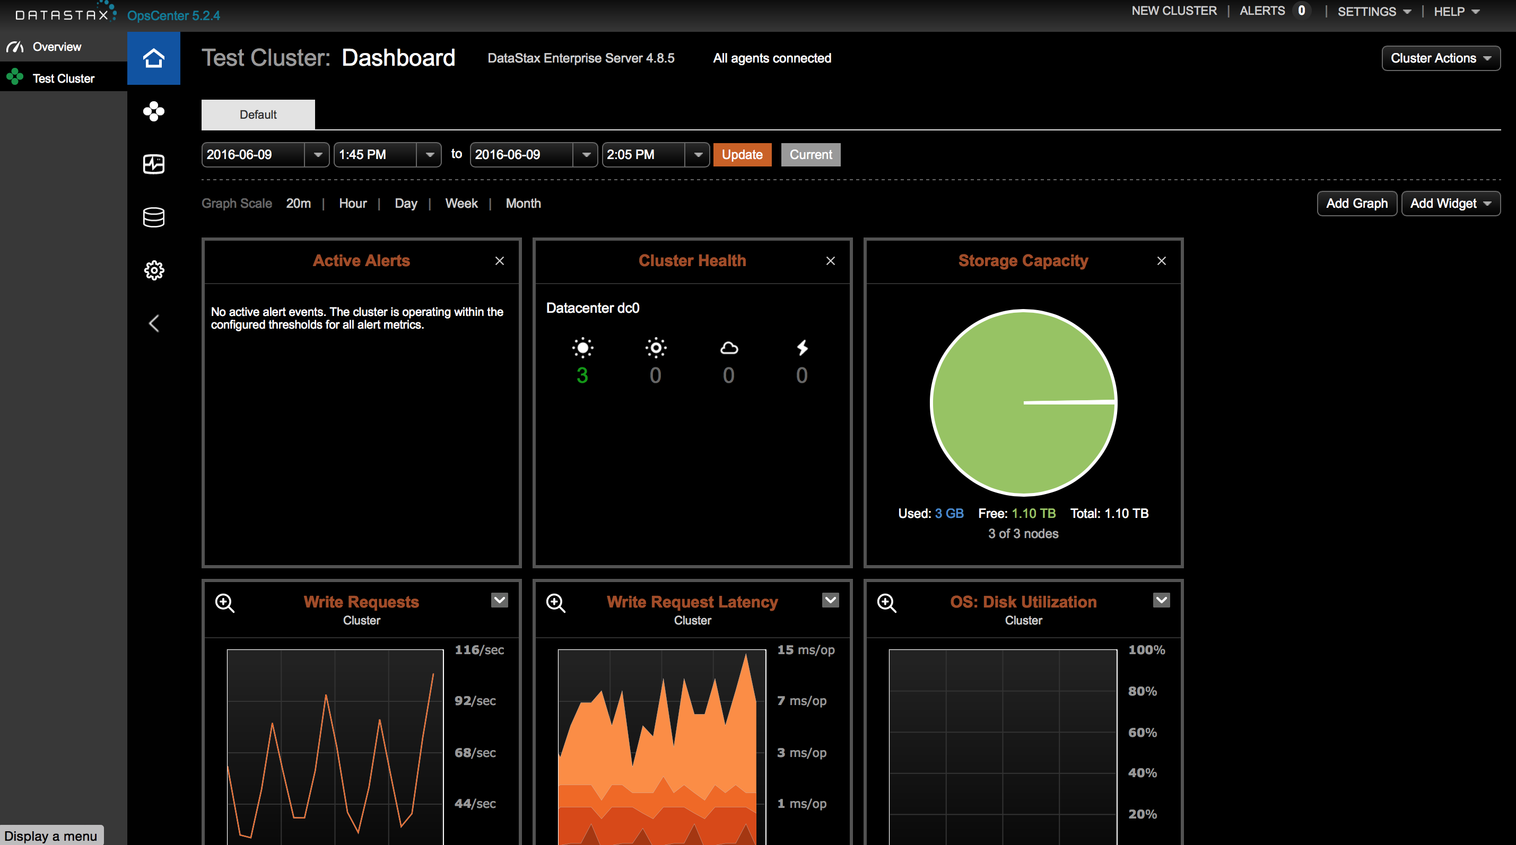

Select Nodes tab:

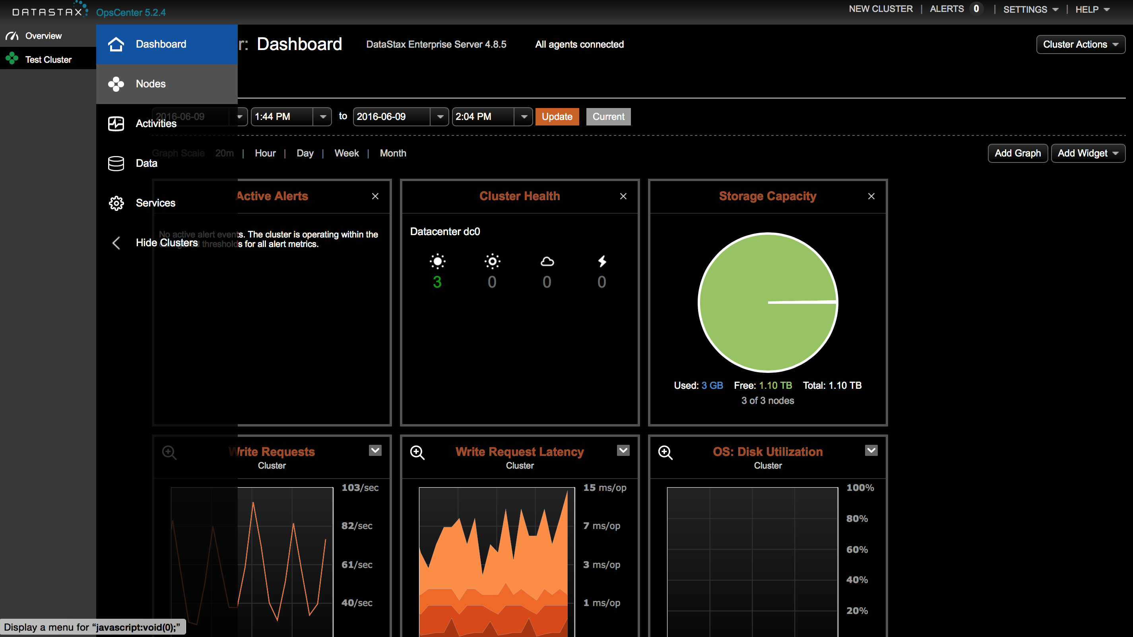

The Nodes view will now appear:

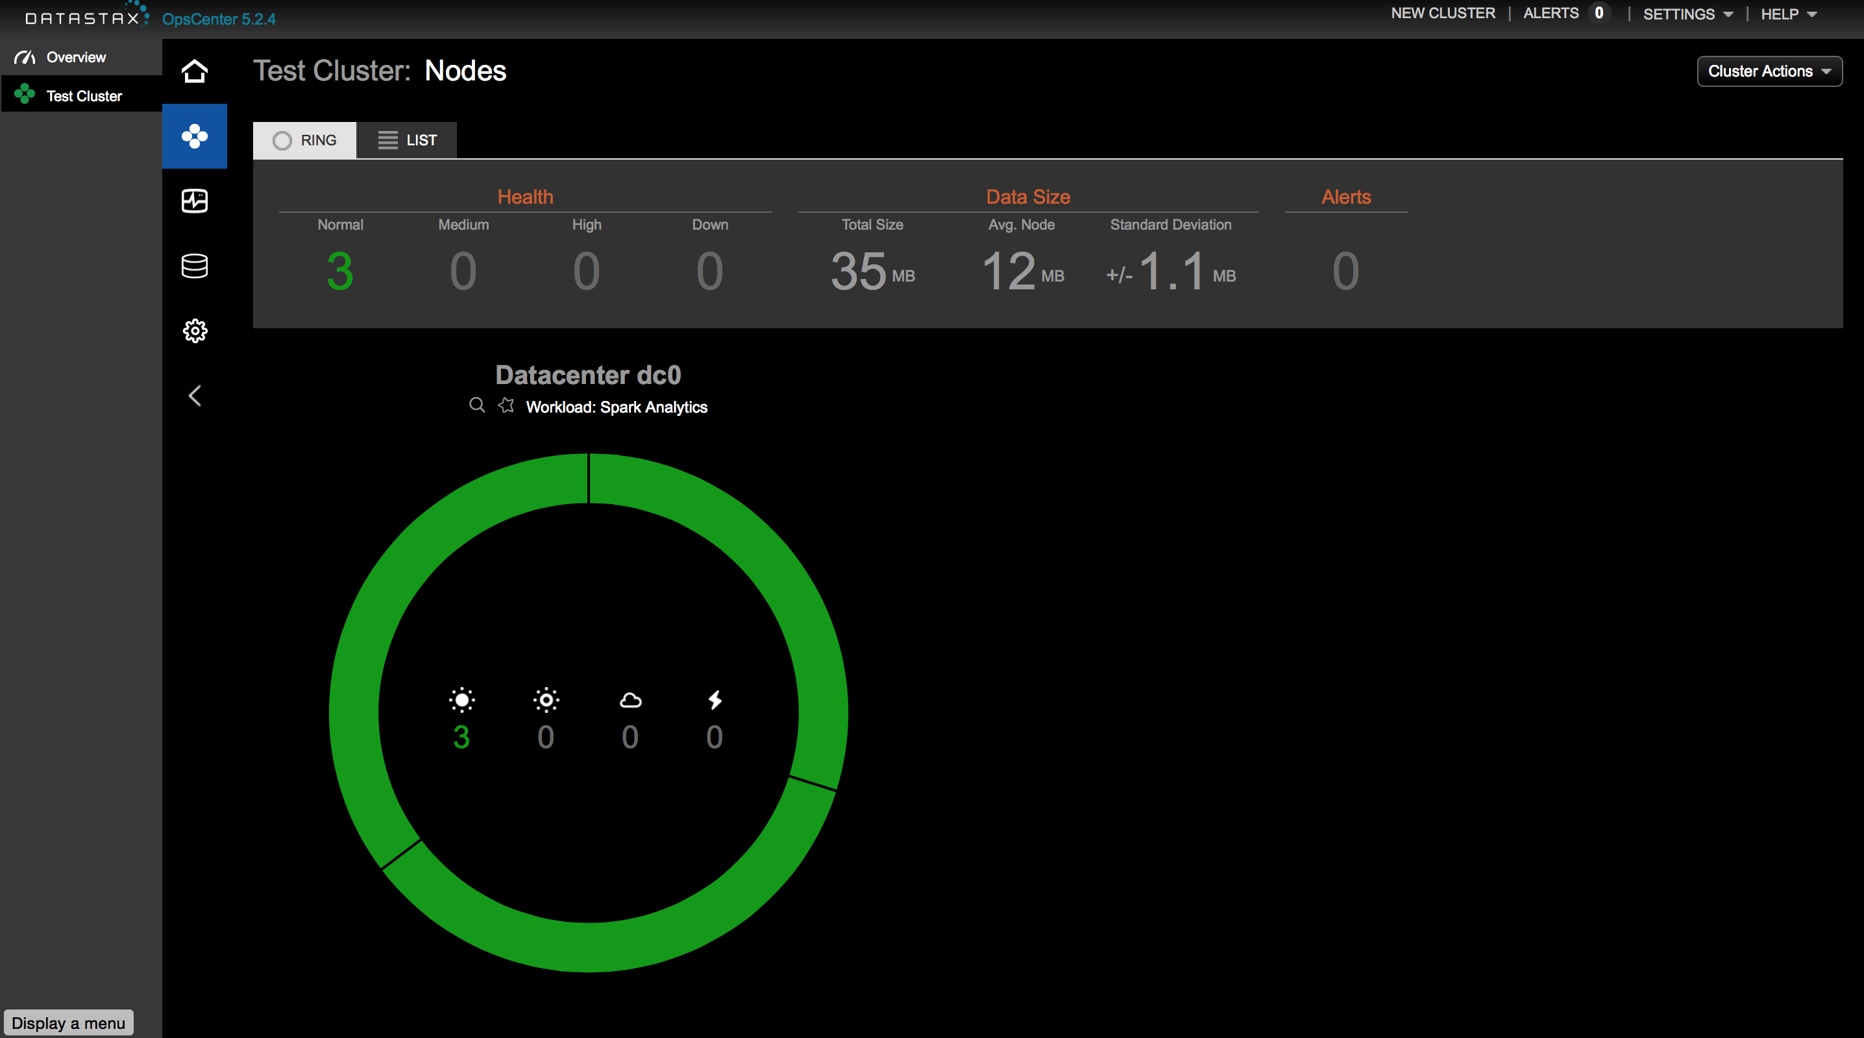

Now, select one of the nodes and double-click on it:

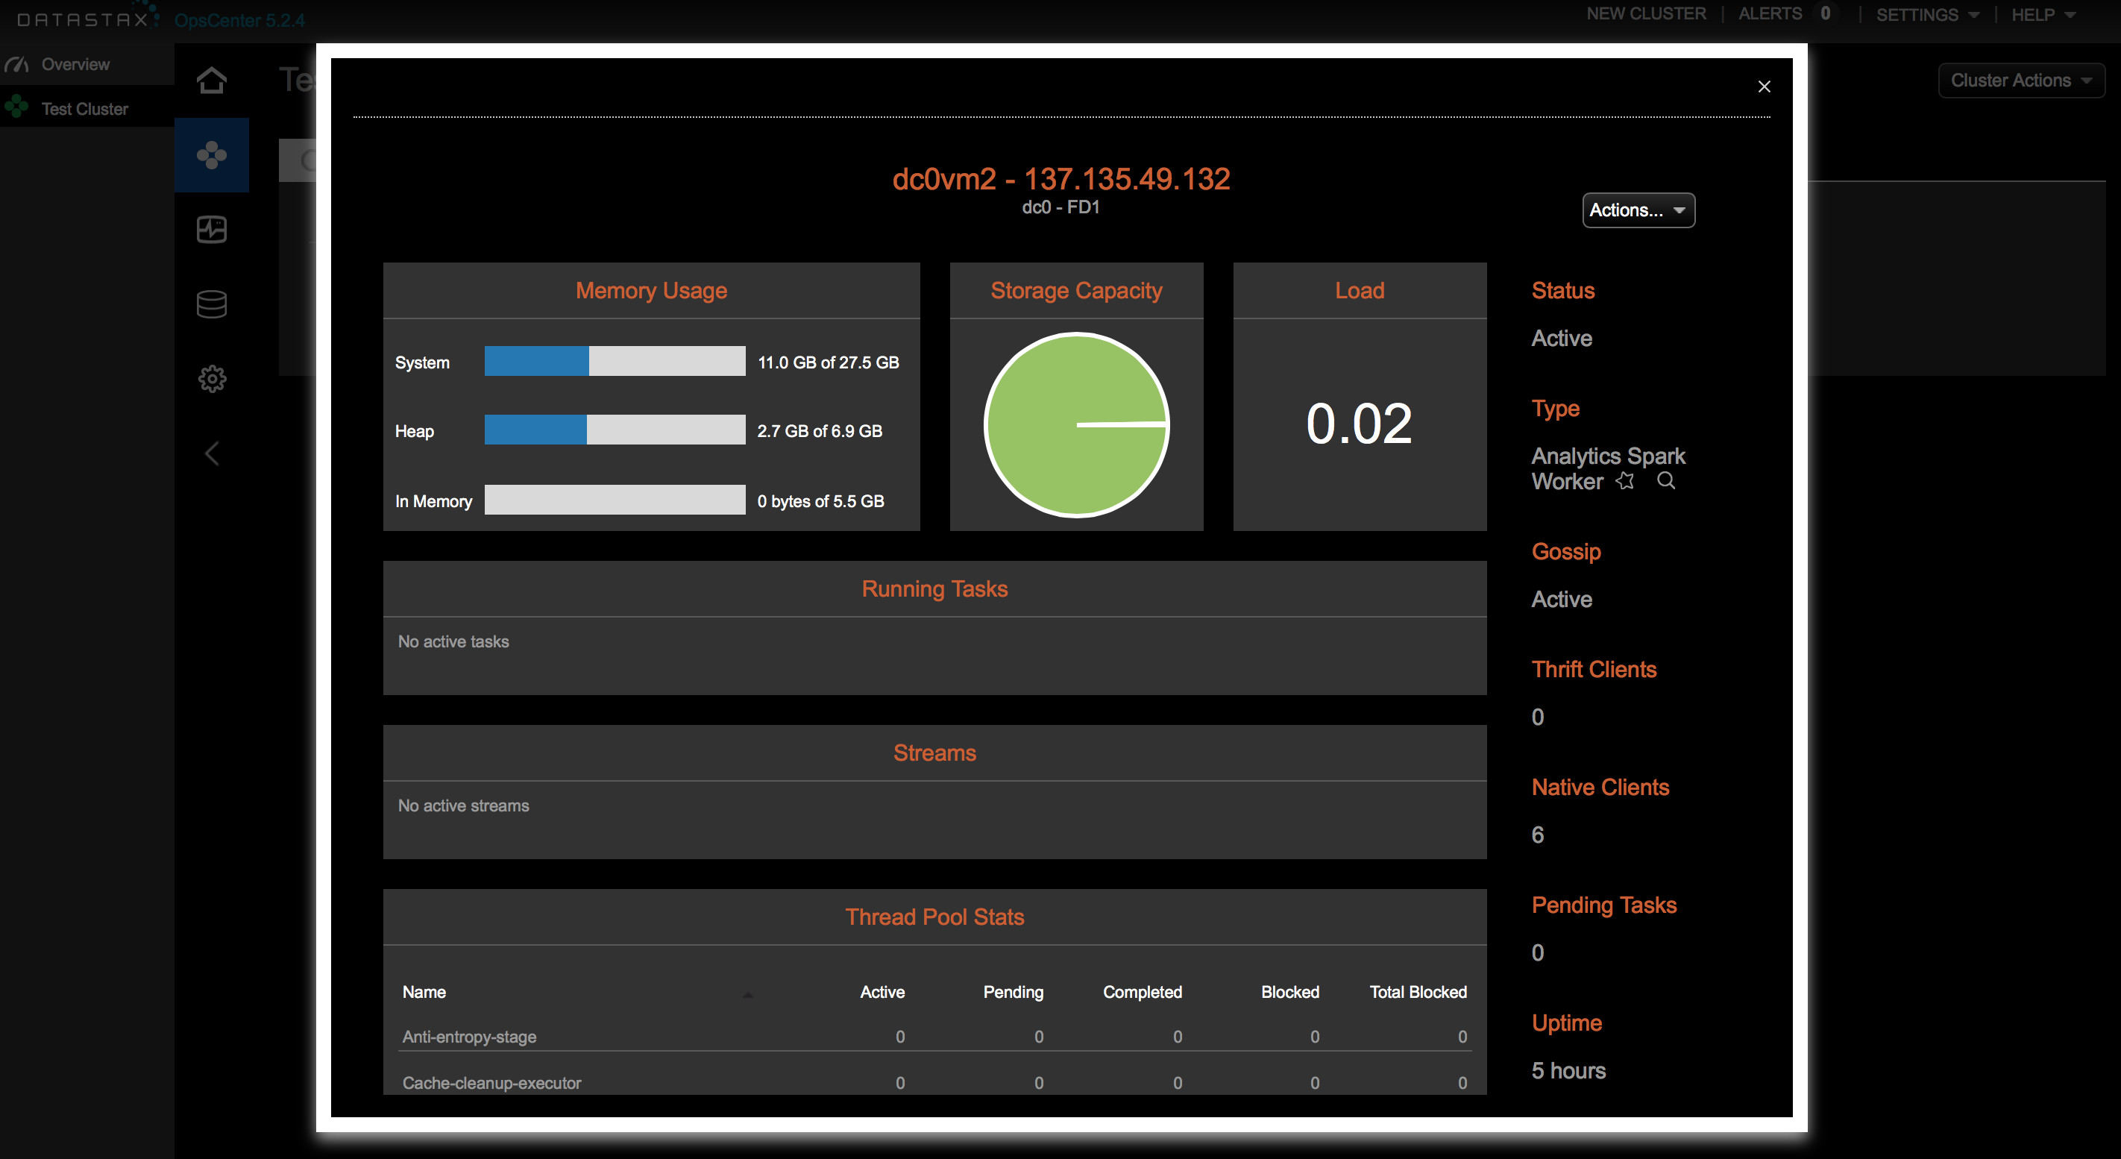

Finally, choose the *Actions…* drop down and select *Stop*:

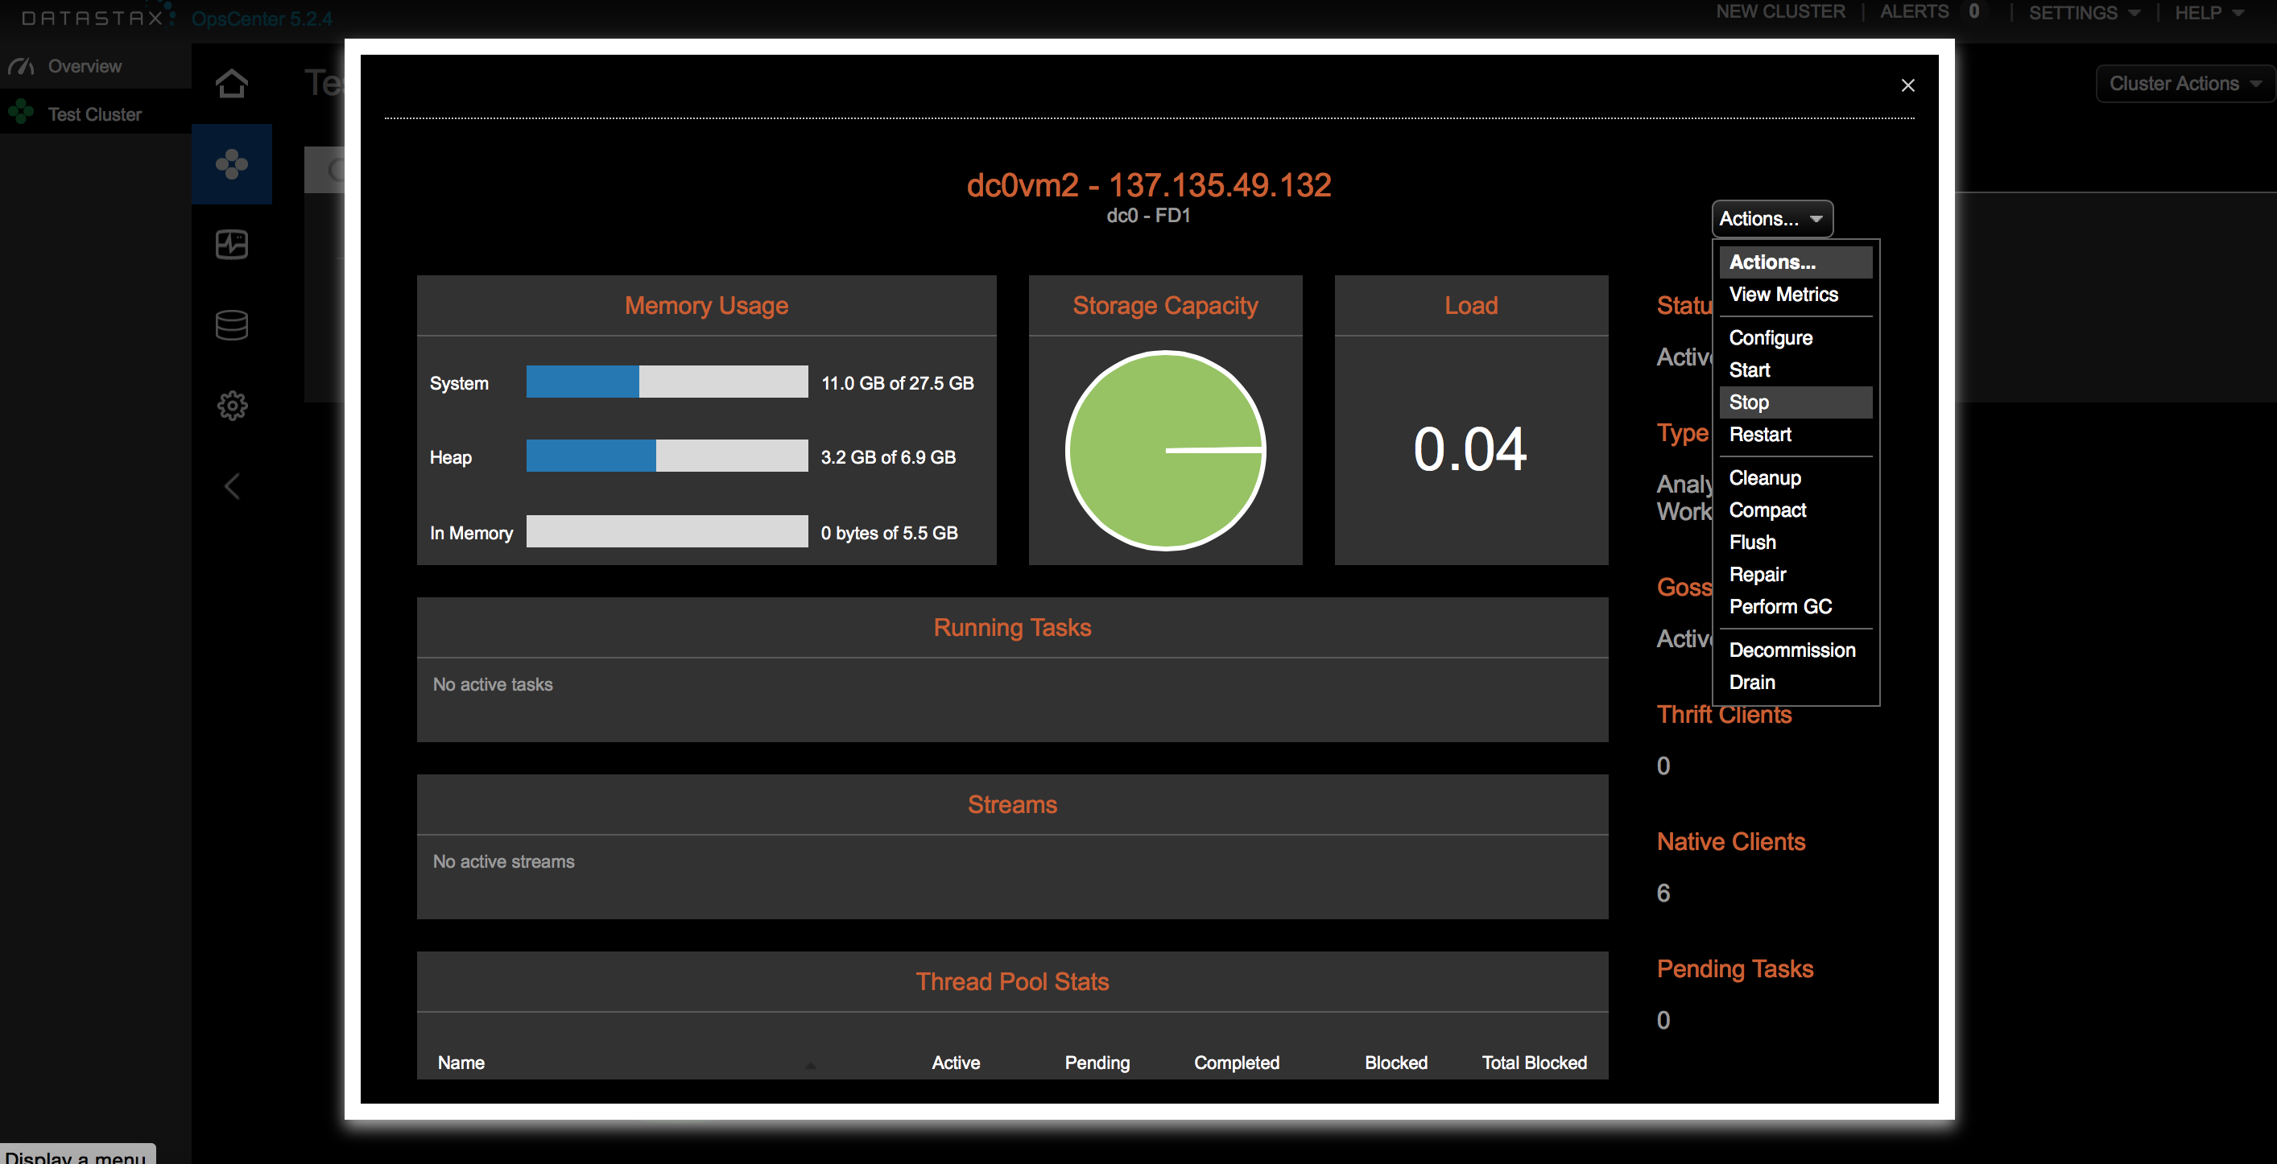

**In CQLSH**:

cqlsh> tracing on

cqlsh> consistency all

Any query will now be traced. **Consistency** of all means all 3 replicas need to respond to a given request (read OR write) to be successful. Let's do a **SELECT** statement to see the effects.

cqlsh> SELECT * FROM retailer.sales where name='<enter name>';

How did we do?

**Let's compare a lower consistency level:**

cqlsh> consistency local_quorum

Quorum means majority: RF/2 + 1. In our case, 3/2 = 1 + 1 = 2. At least 2 nodes need to acknowledge the request.

Let's try the **SELECT** statement again. Any changes in latency?

Keep in mind that our dataset is so small, it's sitting in memory on all nodes. With larger datasets that spill to disk, the latency cost become much more drastic.

**Let's try this again** but this time, let's pay attention to what's happening in the trace

cqlsh> consistency local_one

cqlsh> SELECT * FROM retailer.sales where name='<enter name>';

Take a look at the trace output. Look at all queries and contact points. What you're witnessing is both the beauty and challenge of distributed systems.

cqlsh> consistency local_quorum

cqlsh> SELECT * FROM retailer.sales where name='<enter name>';

This looks much better now doesn't it? **LOCAL_QUORUM** is the most commonly used consistency level among developers. It provides a good level of performance and a moderate amount of consistency. That being said, many use cases can warrant **CL=LOCAL_ONE**.

For more detailed classed on data modeling, consistency, and Cassandra 101, check out the free classes at the DataStax Academy website:

[https://academy.datastax.com](https://academy.datastax.com/)

## Hands On DSE Search

### Search Essentials

DSE Search is awesome. You can configure which columns of which Cassandra tables you'd like indexed in **lucene** format to make extended searches more efficient while enabling features such as text search and geospatial search.

Let's start off by indexing the tables we've already made. Here's where the dsetool really comes in handy:

$ dsetool create_core retailer.sales generateResources=true reindex=true

If you've ever created your own Solr cluster, you know you need to create the core and upload a schema and config.xml. That **generateResources** tag does that for you. For production use, you'll want to take the resources and edit them to your needs but it does save you a few steps.

Now for that description of the *dsetool*. Use the dsetool utility for creating system keys, encrypting sensitive configuration, and performing Cassandra File System (CFS) and Hadoop-related tasks, such as checking the CFS, and listing node subranges of data in a keyspace.

This by default will map Cassandra types to Solr types for you. Anyone familiar with Solr knows that there's a REST API for querying data. In DSE Search, we embed that into CQL so you can take advantage of all the goodness CQL brings. Let's give it a shot.

cqlsh> SELECT * FROM retailer.sales WHERE solr_query='{"q":"name:*"}';

cqlsh> SELECT * FROM retailer.sales WHERE solr_query='{"q":"name:chuck", "fq":"item:*icrosof*"}';

For your reference, here's the doc that shows some of things you can do:

<http://docs.datastax.com/en/datastax_enterprise/4.8/datastax_enterprise/srch/srchCql.html?scroll=srchCQL__srchSolrTokenExp>

### Retail Book Workshop

OK! Time to work with some more interesting data. Meet the Retail book sales data:

Note: This data is already in the DB, if you want to try it at home, click here:

<https://github.com/chudro/Retail-Book-Demo>

First, you’ll need to set this up within your Azure Instances. Pick your dc0vm0 node and log into it.

$ sudo apt-get install python-pip

$ sudo pip install cassandra-driver

$ sudo apt-get install git

$ git clone https://github.com/chudro/Retail-Book-Demo.git

$ cd Retail-Book-Demo/

Run ‘ifconfig’ and look to see what your 10.0.0.x address is.

$ ifconfig

Edit the solr_dataloader.py file

$ sudo vi solr_dataloader.py

Change the line cluster = Cluster(['node0','node1','node2']) to cluster = Cluster(['10.0.0.X’]) Make sure to replace 127.0.0.1 with the IP of the respective node

$ sudo python solr_dataloader.py

$ ./create_core.sh

Example page of what's in the DB:

<https://www.amazon.com/Science-Closer-Look-Grade-6/dp/0022841393?ie=UTF8&keywords=0022841393&qid=1454964627&ref_=sr_1_1&sr=8-1>

Create the click stream data table.Inside *cqlsh*, create the tables you’ll need:

use retailer;

CREATE TABLE retailer.clicks (

asin text,

seq timeuuid,

user uuid,

area_code text,

city text,

country text,

ip text,

loc_id text,

location text,

location_0_coordinate double,

location_1_coordinate double,

metro_code text,

postal_code text,

region text,

solr_query text,

PRIMARY KEY (asin, seq, user)

) WITH CLUSTERING ORDER BY (seq DESC, user ASC);

And book metadata:

CREATE TABLE retailer.metadata (

asin text PRIMARY KEY,

also_bought set<text>,

buy_after_viewing set<text>,

categories set<text>,

imurl text,

price double,

solr_query text,

title text

);

So, what are the things you can do?

**Filter queries:** These are awesome because the result set gets cached in memory.

SELECT * FROM retailer.metadata WHERE solr_query='{"q":"title:Noir~", "fq":"categories:Books", "sort":"title asc"}' limit 10;

**Faceting:** Get counts of fields

SELECT * FROM retailer.metadata WHERE solr_query='{"q":"title:Noir~", "facet":{"field":"categories"}}' limit 10;

**Geospatial Searches:** Supports box and radius

SELECT * FROM retailer.clicks WHERE solr_query='{"q":"asin:*", "fq":"+{!geofilt pt=\"37.7484,-122.4156\" sfield=location d=1}"}' limit 10;

For more info, check out:

<https://cwiki.apache.org/confluence/display/solr/Spatial+Search>

**Joins:** Not your relational joins. These queries 'borrow' indexes from other tables to add filter logic. These are fast!

SELECT * FROM retailer.metadata WHERE solr_query='{"q":"*:*", "fq":"{!join from=asin to=asin force=true fromIndex=retailer.clicks}area_code:415"}' limit 5;

Fun all in one.

SELECT * FROM retailer.metadata WHERE solr_query='{"q":"*:*", "facet":{"field":"categories"}, "fq":"{!join from=asin to=asin force=true fromIndex=retailer.clicks}area_code:415"}' limit 5;

Want to see a really cool example of a live DSE Search app? Check out KillrVideo and its Git to see it in action:

<http://www.killrvideo.com>

<https://github.com/luketillman/killrvideo-csharp>

## Hands On DSE Analytics

Spark is general cluster compute engine. You can think of it in two pieces: **Streaming** and **Batch**. **Streaming** is the processing of incoming data (in micro batches) before it gets written to Cassandra (or any database). **Batch** includes both data crunching code and **SparkSQL**, a hive compliant SQL abstraction for **Batch** jobs.

It's a little tricky to have an entire class run streaming operations on a single cluster, so if you're interested in dissecting a full scale streaming app, check out this git:

<https://github.com/retroryan/SparkAtScale>

Spark has a REPL we can play in. To make things easy, we'll use the SQL REPL:

$ dse spark-sql --conf spark.ui.port=<Pick a random 4 digit number> --conf spark.cores.max=1

Notice the spark.ui.port flag - Because we are on a shared cluster, we need to specify a radom port so we don't clash with other users. We're also setting max cores = 1 or else one job will hog all the resources.

Try some CQL commands:

cqlsh> use retailer;

cqlsh> SELECT * FROM <your table> WHERE...;

And something not too familiar in CQL... SELECT sum(price) FROM <your table>...;

Let's try having some fun on that Book data:

cqlsh> SELECT sum(price) FROM metadata;

cqlsh> SELECT m.title, c.city FROM metadata m JOIN clicks c ON m.asin=c.asin;

cqlsh> SELECT asin, sum(price) AS max_price FROM metadata GROUP BY asin ORDER BY max_price DESC limit 1;

## Getting Started with DSE Ops

Most of us love to have tools to monitor and automate database operations. For Cassandra, that tool is DataStax OpsCenter. If you prefer to roll with the command line, then two core utilities you'll need to understand are nodetool and dsetool.

Utilities you'll want to know:

* nodetool //Cassandra's main utility tool
* dsetool //DSE's main utility tool

nodetool Examples:

Shows current status of the cluster:

$ nodetool status

shows thread pool status - critical for ops:

$ nodetool tpstats

dsetool Examples:

Shows current status of cluster, including DSE features:

$ dsetool status

Will create a Solr schema on Cassandra data for Search:

$ dsetool create_core

The main log you'll be taking a look at for troubleshooting outside of OpsCenter:

/var/log/cassandra/system.log

# About DataStax

DataStax, the leading provider of database software for cloud applications, accelerates the ability of enterprises, government agencies, and systems integrators to power the exploding number of cloud applications that require data distribution across datacenters and clouds, by using our secure, operationally simple platform built on [Apache Cassandra™](http://cassandra.apache.org/).

With more than 500 customers in over 50 countries, DataStax is the database technology of choice for the world’s most innovative companies, such as Netflix, Safeway, ING, Adobe, Intuit, Target and eBay. Based in Santa Clara, Calif., DataStax is backed by industry-leading investors including Comcast Ventures, Crosslink Capital, Lightspeed Venture Partners, Kleiner Perkins Caufield & Byers, Meritech Capital, Premji Invest and Scale Venture Partners. For more information, visit [DataStax.com](http://www.datastax.com/) or follow us [@DataStax](https://twitter.com/datastax).